

**ECHO Investment S.A.**

ESSV Executive Site Safety Visits

Tour Pack

*Version 1.5*

- December 2022 -

Section 1. Introduction 3

Section 2. Tour guidelines 4

Requirements of Tour Party 4

Requirements of Project Team 4

The Site Tour 4

Reporting 5

Feedback 5

Close Out 5

Section 3. Guidance Notes 6

1. Induction training 6

2. Procurement 6

3. Design 6

4. Environmental Impact 6

5. Works planning 7

6. Competence/ Supervision 7

7. Priorities/ Construction Site 8

8. Discipline/ Reward 8

9. Visible Leadership 8

10. Permits to Work 9

11. Perception 9

12. Targets 9

13. Active Monitoring 9

14. Emergency Procedures 9

15. Toolbox Talks/ Initiatives 10

16. Visual Impact/ Public/ Welfare 10

17. Project Plan (Plan BIOZ) 10

18. Pollution Prevention 10

19. Accident Investigation 11

# Section 1. Introduction

The ESSV Tour programme is to implement, in the year 2018. The tour parties include the senior members of Project Teams, therefore widening the participation and enabling all participants to achieve maximum benefit.

The tours are designed to enable the key decision makers of the business to share best practice, transfer learning and conduct peer reviews.

The tours also allow for a compliance check and enable a degree of monitoring.

Agenda for each Tour:

* Induction
* Project EHS documentation Review
* Site Tour
* Tour Party Consultation
* Feedback within 7 days

# Section 2. Tour guidelines

The Tour Party will liaise with each other and agree a tour date with the respective Project Manager/Project Director at least one week before planned date, so as to ensure that the necessary people are available on the day.

**Attention!** It is important to plan visits at various locations (also different cities), which aims to equalize the level of project visits, leveling standards and an even level of monitoring.

The tour date when agreed is notified to the local EHS Manager so the tour programme can be kept up to date.

A copy of the completed tour report is sent to the EHS Manager.

The Tour Party need to ensure that the Report is closed out within an agreed timescale and forwarded to the EHS Manager by site team.

## Requirements of Tour Party

The Tour Party will ensure that at least 10 categories are reviewed and scored on each visit with the following included in every case:

* Induction training
* Procurement
* Design
* Environmental Impact
* Works Planning
* Competence/ Supervision
* Priorities/ Construction Site

## Requirements of Project Team

The Project Manager/Project Director must ensure that essential team members are available on the day of the tour.

The site team will ensure that the Tour Team receive a full Induction on the site and by the person who generally carries out the Induction.

Project Managers/Project Directors are to action feedback from the Tour at the earliest appropriate time.

The project team are required to demonstrate sufficient evidence, to the tour party, of how EHS is being managed on the project.

## The Site Tour

The site tour is the opportunity for the touring team to experience the site culture and observe with the eye. See, feel & hear.

Tour members are encouraged to introduce themselves to a number of operatives and establish whether they the operatives consider that EHS is high on our agenda and whether they consider us to be committed to producing a safe working environment.

The Tour report should be based on what they hear, feel and see and as such will be a measure of the culture existing on the project in question.

## Reporting

Once the tour has been completed the tour party will complete the ESSV Tour Report form. Three copies are required:

* Tour party
* Project
* EHS Manager

## Feedback

At the end of the tour, the tour party should then hold a feedback session with the Project Manager, Project Director and his team.

## Close Out

Any actions arising from the tour should be closed out by the Project Director in a timely manner. This action should be confirmed to the Tour Party and the Company Health & Safety Manager within 7 days.

# Section 3. Guidance Notes

## Induction training

The Induction process is intended to communicate to ALL personnel/visitors the requirements of the project:

* How well is the EHS Induction training delivered?
* Has the latest version of the training presentation been used in accordance with the Echo template "EHS Induction visitors", are pictures from construction site used in presentation?
* Has it been issued for signature after the introductory training for guests the attendance list "Training Record"?
* Is the quality of the room acceptable?
* Are the currently occurring occupational health and safety hazards at the construction site discussed?
* Whether the current presentation of Echo "Information training for employees" was used to train new contractors' employees, how are the employees trained (where, is the projector, attendance list, etc.) used?

## Procurement

* Has the " Tradecontractor EHS questionnaire" questionnaire been provided and discussed for each Contractor?
* Has any meeting been held with any Contractor before the commencement of the works and a document " Pre-start meeting agenda" was prepared?
* Have references been provided?
* How were the competencies of individual employees assessed, did the Contractor provide a completed " Contractor's list of employees and equipment"?
* Has the process made it possible to exclude incompetent Contractors?

## Design

* Have Designers taken steps to reduce risks?
* Evidence? Project Risk Register, CDM Design HS Guidelines Checklist, CDM Designer HS information;
* Has the information been assessed and communicated?
* Is the Designers safety professional operating effectively?
* Did Designers propose / design a temporary system edge protection for balconies?

## Environmental Impact

* Are all significant environmental risks on the project described in the "Project Risk Register" ?;
* Has the "Environmental investigation of Buildings" (if applicable) been carried out?
* Has the "Environmental investigation of Land" been carried out?
* Does the team know and knows where to find current environmental goals?
* Did the team limit the use of hazardous, toxic materials?
* Have COSHH hazardous substance cards been implemented?
* Are the planned goals implemented and how are they monitored?
* Does the project achieve the BREEAM level planned at the design stage (if applicable)?
* Has a notification to the BDO Waste Database been made by a construction waste producer.
* Obligatory to check! Does the construction site implement a media saving program in accordance with the list “Echo limiting media consumption at the construction site”?

There should be objective evidence of the following:

* Waste minimisation in practice?
* Obligatory to check! Segregation of waste on the construction site? Has the construction site provided space and containers for selective waste collection, broken down into at least: hazardous waste, wood, metals, glass, plastics, gypsum, mineral waste, including concrete, brick, tiles and ceramic materials, and stones?
* Waste segregated on site?
* Rubbish removed to skips each day?
* Is waste segregated, if so to how many factions?
* Hazardous waste skips identified?
* Are waste containers overfilled?
* Is the documentation stored - waste transfer cards?
* Are waste transfer cards handed over by the waste recipient on a regular basis?
* Is a collective waste list maintained?

## Works planning

* Risk Assessments should be produced and submitted by ALL trade contractors and where there are shared risks/interfaces these may need to be supplemented by risk assessments carried out by the project team.
* Has the "Project Risk Register" been developed in accordance with the Echo model? Are main H&S risks described?
* Is Method Statement developed for selected works and Risk Assessment is available (for the job or for job positions)?
* Is the supervision mentioned / described in the Method Statement?
* Is the full work sequence (from material delivery, transport and installation) described in the Method Statement?
* Have the employees confirmed the acquaintance of the Method Statement with the signature?
* Have the work been approved by ECHO / General Contractor before the start?
* Does Method Statement in the case of performing particularly dangerous work (e.g. works at heights) explain in a clear way for employees, gives knowledge about the methods of personal protection - taking into account the specificity of performing work?
* Have transportation works (horizontal and vertical transport) been described in the Risk Assessment and Method Statement?

## Competence/ Supervision

* How is the verification of employees competences carried out?
* Has it been provided by each Contractor "Contractor's list of employees and equipment", whether all information has been completed or is it signed?
* Do the equipment operators have the necessary authorization to operate it?
* Do the designated contractors' supervisors have periodic H&S training for employers or managers of employees? How is this verified?
* Check the awareness of ECHO employees, understanding their tasks and responsibilities.
* Are designated EHS Coordinators competent?
* Is the supervisor identified –colour coded helmets (white)?
* Have the number of direct supervisors been verified on site according to the rule 1/10 (at least one supervising employee per ten employees), is supervision visible at the construction site?
* Has he put his men to work?
* Supervision competent?

## Priorities/ Construction Site

**Each time you should check** (if currently executed):

* Are there any measures taken by construction sites to reduce utility consumption? If so, what are they?
* Is there a designated person for ongoing media consumption monitoring?
* Are the rules of media reducing communicated to employees during the HSE information training?
* Is media consumption periodically (at least once a month) discussed with Contractors at a coordination meeting?
* Has the construction site welfare containers standard been implemented in accordance with Echo's guidelines for new projects?
* Have system protections been implemented when working at height when concreting columns and walls: steel railing and working platform or ensuring high H&S standard for access equipment (e.g. scaffolding)?
* In case of collision conditions do the tower/truck mounted cranes have been equipped with anticollision system?
* Have the slingers and signalists functions been separated for vertical transport?
* Are the loads transported correctly (slings and attachment method) in accordance with the DTR?
* Do signalists have walkie-talkies, whistles and directional lines?
* Is work at height secured with use of temporary system edge protection?
* Is temporary edge protection installed correctly, complete / of the right height (upper edge of the barrier min. 1.1 m)?
* Do employees use correct personal protection (fall restraint, not starting the fall - the right length of the rope and anchor points) in places where collective protection cannot be applied?
* Has proper danger zones (falling objects) been marked under work at height, is there protection against falling objects (nets, canopies)?
* Have adequate pedestrian paths separated from the road roads been provided, or is there safe access to the site welfare (outside hazardous areas, e.g. falling objects)?
* Has a banksmen person been provided to steer traffic (e.g. reversing vehicles)?
* Are there system stairs for communication between different levels?
* Is there general housekeeping at the construction site?
* Is construction supervision effective?

## Discipline/ Reward

**Discipline**

* Is there a discipline procedure in place on the project (i.e. Yellow card – red card )?
* Was the discipline procedure identified in the Induction?

**Reward**

* Is there a reward system in place on the project?
* Was the reward procedure identified during the Induction?
* Does the award ceremony take place during a meeting with all construction workers?

## Visible Leadership

* How do the key decision makers and leaders on the project set and maintain standards?
* Is there evidence of direct action & leading by example?
* What is the frequency and duration of site tours?
* Is there evidence of interaction with the workforce?
* How are rule breakers dealt with?
* Take into account the Health and Safety culture. Is it created by leadership at the construction site?
* Does PM participate in internal ISO 14001/45001 audits (once a year) and min. once a month in a Peer Review or ESSV at your construction site?
* Does PM carry out two visits, Site Manager one visit per quarter on construction sites other than PM/DB, ESSV or Peer Review)?
* Are EHS issues discussed at the weekly meetings at the construction site? Are there any records from such meetings confirming the inclusion of EHS issues?

## Permits to Work

* Is the work permit system in use on the project: "Lifting permit - mobile cranes"; "Lifting permit- tower cranes", "Confined space entry permit", "Hot works permit", “Excavation permit”?
* Is the "Concrete pump checklist" kept up to date?
* Are the Permit for Work Coordinators appointed?
* Are the designated persons under the control of the permit system?
* Did you have training in issuing a permit for high risk activities on a given construction site?
* Are all required fields filled out in the work permit form, is the document signed?

## Perception

Select one or two employees from each trade contractor and ask:

* If they have received an EHS Induction training?
* Were they put to work today ?
* Have they taken part in a toolbox talk?
* How do they think ECHO manages EHS?
* How do we carry out workforce consultation? Are meetings organized (10-15 minutes) in order for employees to comment on the state of health and safety on the project?

## Targets

* Does the construction supervision know the current EHS goals of Echo?
* Does the construction supervision know where the EHS objectives are described?
* Are the progress monitored?
* Are the goals achieved?
* Is Echo EHS Policy prominently displayed on site?

## Active Monitoring

Records of EHS inspections should be completed

* Is the site team carry weekly Peer Reviews?
* Are the inspection reports sent on an ongoing basis to the EHS department?
* Are the recommendations from the reports closed out regularly?
* Do the Contractors take part in site inspections?
* Is the construction site in a timely manner forward to EHS department Echo " Project EHS Monthly Report" and "Quarterly Health and Safety Report"?

## Emergency Procedures

Emergency Plans are required on every project, must be displayed in a prominent position and will include:

* Has the “Emergency Preparedness Plan” been developed according to the Echo pattern?
* The Fire Escape plan and procedures?
* Spill control plan and procedures?
* Were Emergency Procedures identified in the Induction?
* Have key personnel been identified in the plans (i.e. Fire Wardens)?
* Does the project have records of regular testing of the warning system?
* Is there sufficient and appropriate signage? Both for information and emergency in both offices and sites.
* Is there sufficient access for emergency vehicles on site?

## Toolbox Talks/ Initiatives

Toolbox talks are the prime source of communicating information to individuals at site. There should be evidence at site of:

* Toolbox talks being available?
* Are employees familiar with the IAN information about accidents and incidents, if so, how?
* Records of attendance for talks given?
* Does the toolbox talk have the right effect?
* Have the site engaged in any EHS initiatives f.i National Labour Inspectorate Contest, testing of new solutions etc.?
* Are these initiatives explained at orientation?
* Is the information being fed back into the main business?

## Visual Impact/ Public/ Welfare

* Material storage;
* Housekeeping;
* Does it look like a ECHO project?
* External relationships;
* Security - including construction fencing and access control;
* Signs & information – including safety board and mirror;
* Welfare facilities;
* First aid – first aid box available?
* Drinking water;
* Changing, drying and storing clothes?

## Project Plan (Plan BIOZ)

* Is the document up to date?
* Did the last revision of the BIOZ Plan take place no later than every 6m, is there a list of revisions attached?
* Are specific project needs referred to?
* Is there a list of Contractors with contact details in the BIOZ Plan?
* Does the document have a date and is signed?

## Pollution Prevention

* Potential sources of pollution?
* Has a risk assessment been carried out?
* All fuel and oil storage areas properly bunded?
* Are spill kits in placed and signed?
* Is dust & noise under control?

## Accident Investigation

* Does the construction site team report serious incidents and accidents at work?
* Is the current IAN information displayed on the EHS board?
* Does the construction site provide information on the actions taken after the IAN events to the EHS Department on a regular basis?
* Is there evidence of lessons learned?

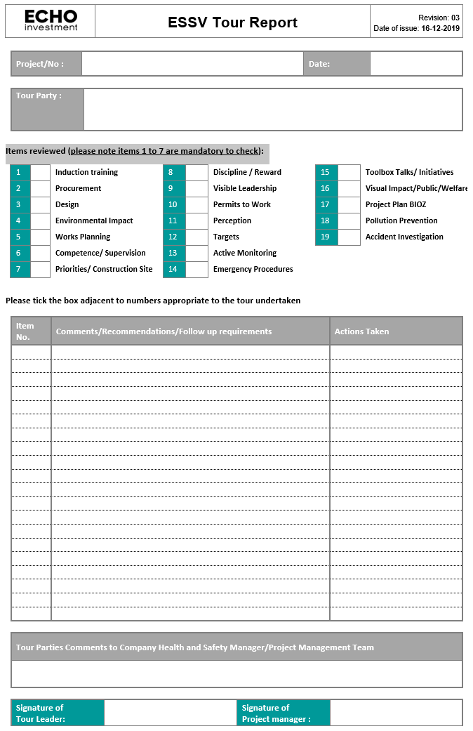

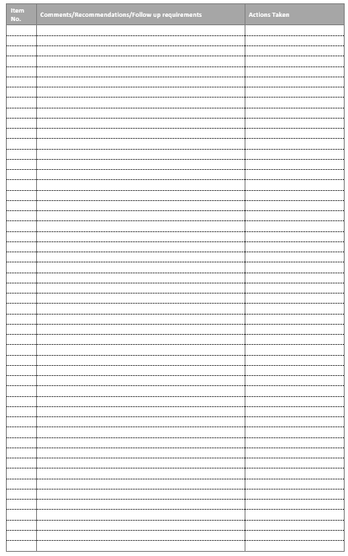

|  |  |
| --- | --- |
| **ECHO Investment S.A.**  Head Office in Kielce  25-323 Kielce  Al. Solidarności 36  Tel. +48 41 33 33 333  e-mail: office@echo.com.pl | **ECHO Investment S.A.**  Warsaw  00-133 Warszawa  Al. Jana Pawła II 22  Tel. +48 22 4 300 300  e-mail: info-warszawa@echo.com.pl |